PIZZA SALES SQL QUERIES
A. KPI’s
1. Total Revenue:
select round(sum(total_price),2) as total_revenue from pizza_sales;
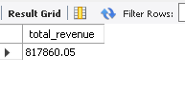
2. Average Order Value
SELECT ROUND(SUM(total_price) / COUNT(DISTINCT order_id), 2) AS avg_order_value
FROM pizza_sales;
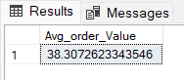
3. Total Pizzas Sold
select sum(quantity) as total_sales from pizza_sales;
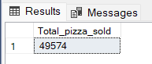
4. Total Orders
select count(distinct order_id) as total_orders from pizza_sales;
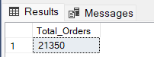
5. Average Pizzas Per Order
select sum(quantity)/count(distinct order_id) as avg_pizza_perorder
from pizza_sales;
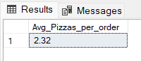
B. Daily Trend for Total Orders
SELECT DAYNAME(order_date) AS order_day,
COUNT(DISTINCT order_id) AS total_orders
FROM pizza_sales
GROUP BY DAYNAME(order_date)
order by COUNT(DISTINCT order_id);
Output:
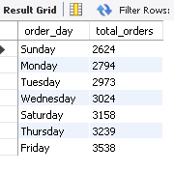
C. Hourly Trend for Orders
SELECT HOUR(order_time) AS order_hours,
COUNT(DISTINCT order_id) AS total_orders
FROM pizza_sales
GROUP BY HOUR(order_time)
ORDER BY order_hours;
Output
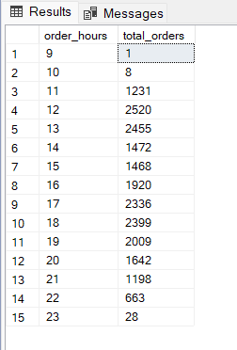
D. % of Sales by Pizza Category
SELECT pizza_category,
ROUND(SUM(total_price) * 100 /
(SELECT SUM(total_price) FROM pizza_sales WHERE month(order_date)= 1), 2) AS percentage
FROM pizza_sales
WHERE month(order_date) = 1
GROUP BY pizza_category;
Output
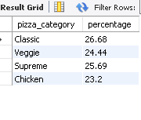
E. % of Sales by Pizza Size
SELECT pizza_size,
ROUND(SUM(total_price) * 100 /
(SELECT SUM(total_price)
FROM pizza_sales
WHERE QUARTER(order_date) = 1), 2) AS PCT
FROM pizza_sales
WHERE QUARTER(order_date) = 1
GROUP BY pizza_size
ORDER BY PCT DESC;
Output
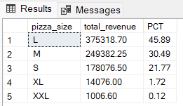
F. Total Pizzas Sold by Pizza Category
select pizza_category,sum(quantity) as Total_pizza_sold
from pizza_sales
group by pizza_category;
Output

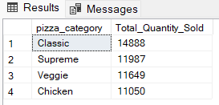
G. Top 5 Best Sellers by Total Pizzas Sold
select pizza_name,sum(quantity) as total_pizza_sold
from pizza_sales
group by pizza_name
order by sum(quantity) desc
limit 5;
Output
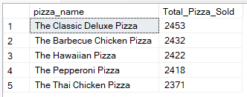

H. Bottom 5 Best Sellers by Total Pizzas Sold
select pizza_name,sum(quantity) as total_pizza_solds
from pizza_sales
group by pizza_name
order by sum(quantity) asc
limit 5;
Output
